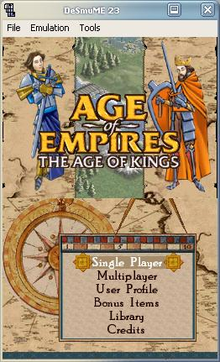
DeSmuME is the first Nintendo DS emulator able to run some commercial games at a playable level.

